Christopher Corr

Lab 4

IT 231

Professor Debettencourt

* Uploaded all of the required files to codeanywhere terminal

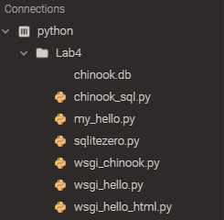

* This is the line of code that request information from the database regarding the genres contained

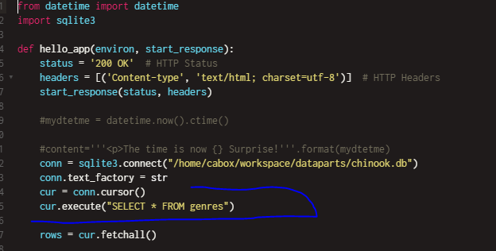

* This code allows for us to gather the artists’ information contained within the given database

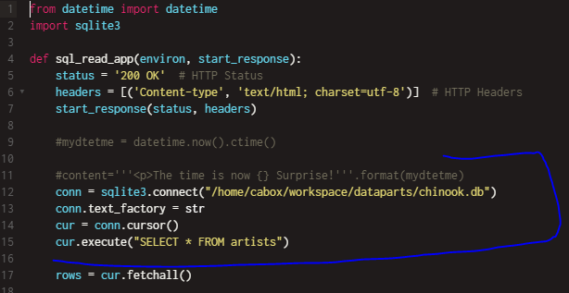

* All of the information contained within this file is our database. This is what we are searching through for various queries.

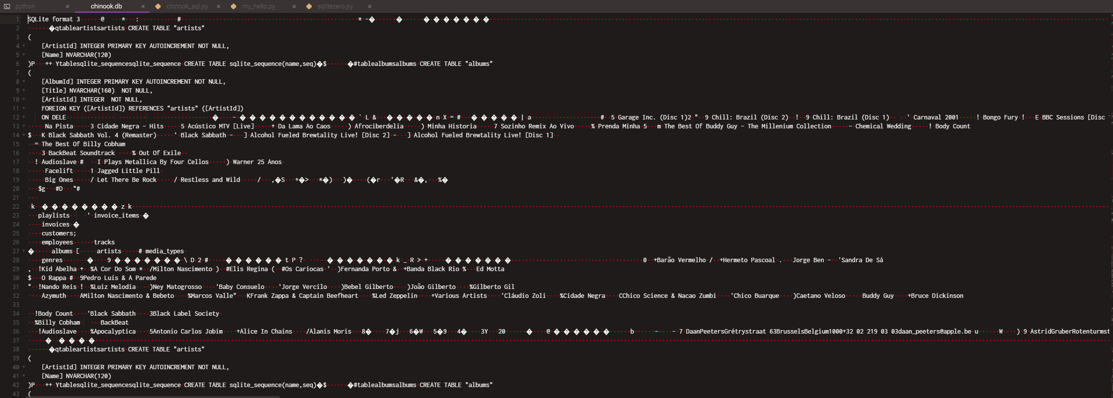

* This code in the wsgi_hello_html.py file allows for us to create a server on port 8000 and run the codes

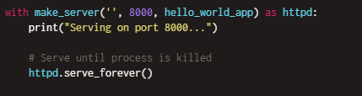

* This code in the wsgi_chinook.py file allows for us to create and run a server on port 3000

